Part 1: Environment Setup:
Task 1.1: Start the Docker Compose Environment:
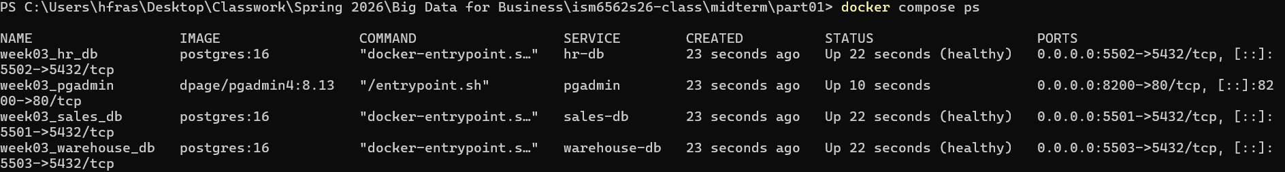
Task 1.2: Connect to Each Database via psql:
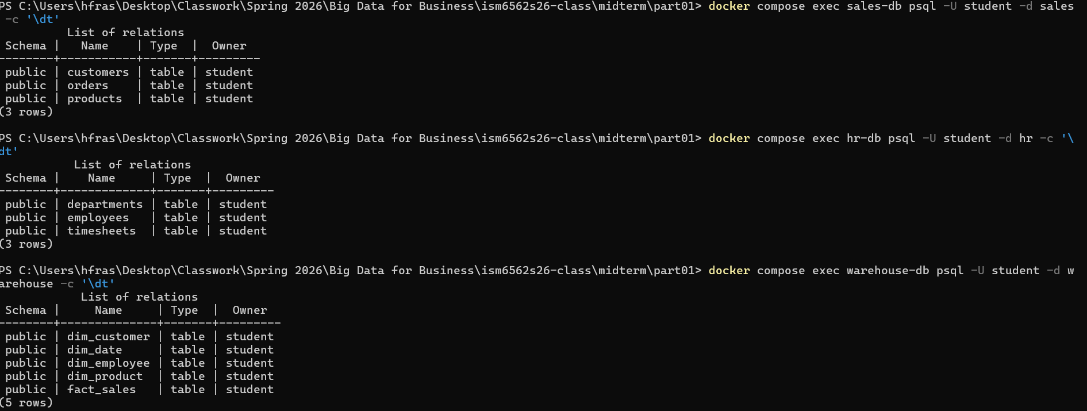
Task 1.3: Register All Three Servers in pgAdmin:
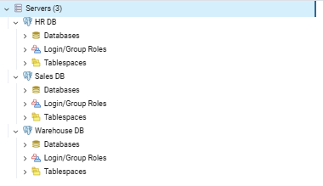

Part 2: Explore Operational Databases:
Task 2.1: Examine the Sales Schema:
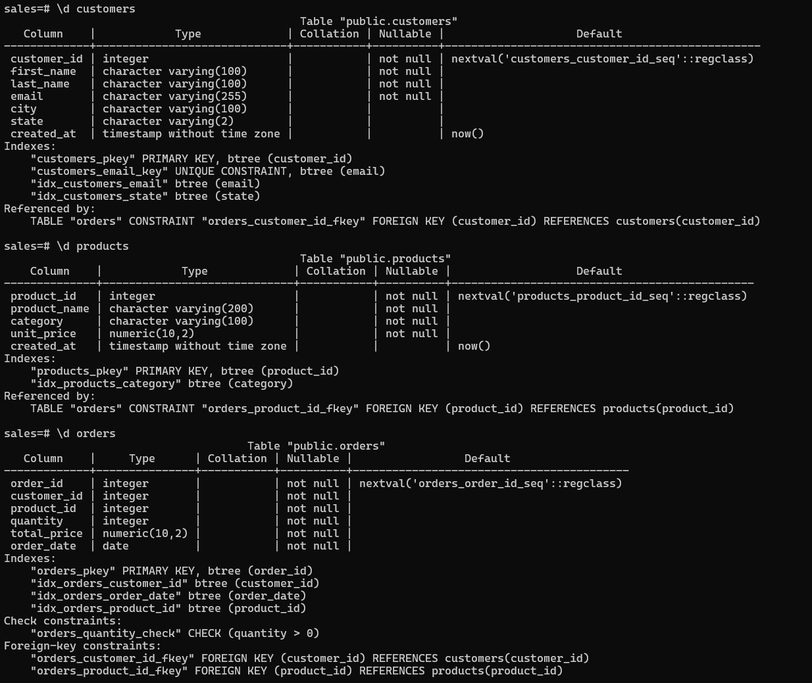
The sales schema demonstrates normailization by following third normal form, each piece of data will live in exactly one place. We can see this with the primary keys (customers table has customer_id products table has product_id and orders table has order_id) and we can see that the orders table references customer_id and product_id. This avoids redundancy because the customers information, like their name, email, city, and state, and product information like name, category, unit price, all have their own tables, so instead of putting their information each time there is an order we would just do that once in the customer and products table and the use FKs to reference them.
Task 2.2: Examine the HR Schema:
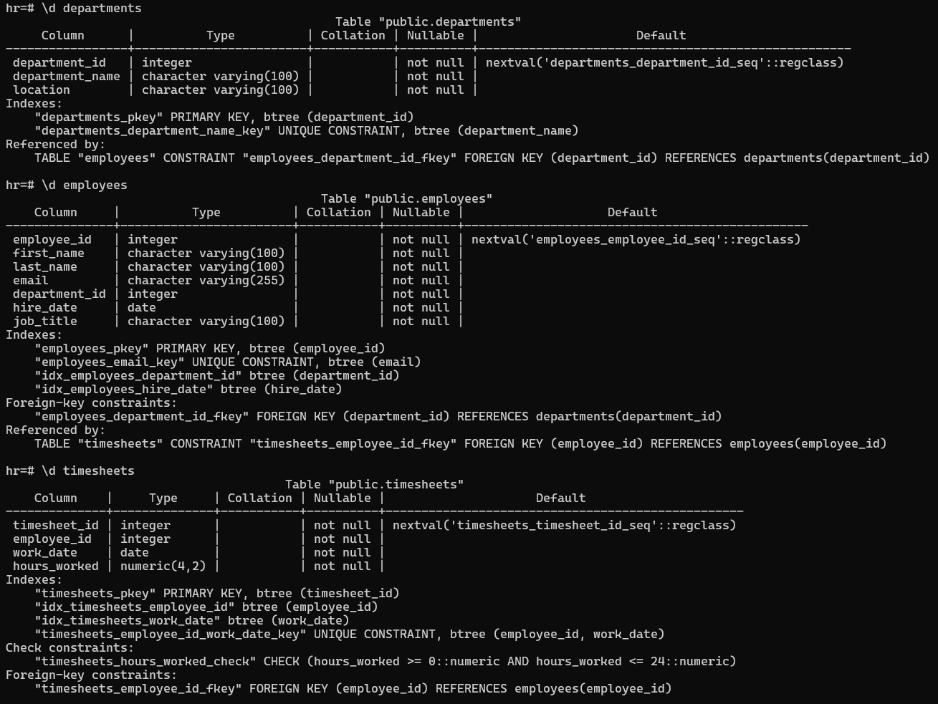
The relationship between the three are departments to employees to timesheets. Employees has a FK department_id meaning that every employee must belong to a department. Timesheets has a FK employee_id, meaning that every timesheet entry must belong to an employee. The UNIQUE constraint means that the combination of employee_id and work_date must be unique. This ensures that an employee has one time sheet per work day and that they cannot double dip, and to make sure that the employee does not accidently, or abuse the time sheet and clock in for extra hours. They work their day and go home.

Task 2.3: Run Queries Against the Operational Databases:
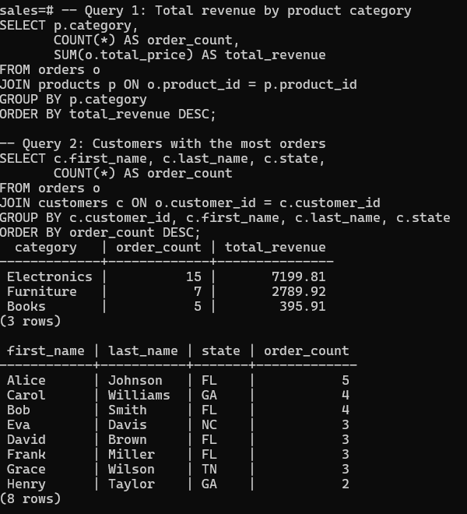
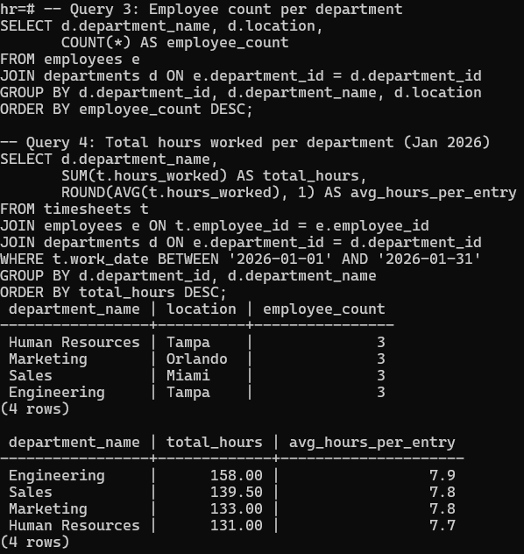

Part 3: Data Warehouse Concepts:
Task 3.1: Examine the Star Schema:
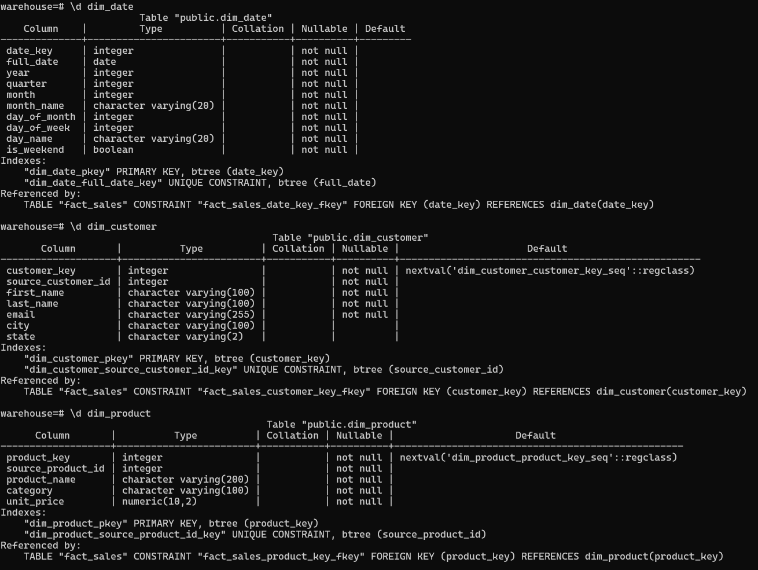
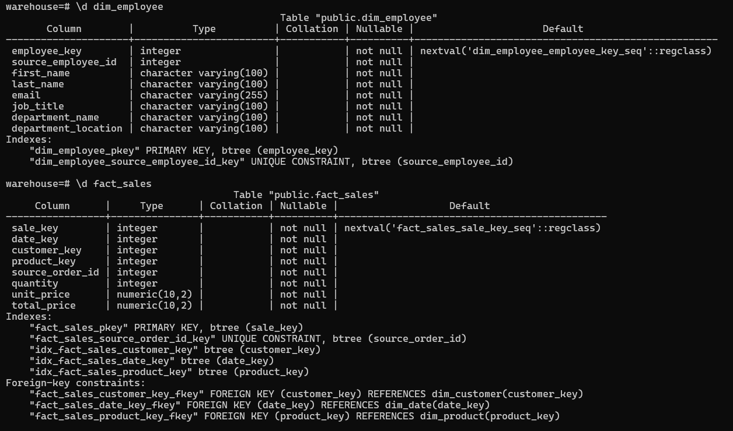

Task 3.2: Compare Operational vs Warehouse Design:
In the operational database the customers and the products are stored in their own tables that are normalized and they are linked to each other through foreign keys in the orders table. The warehouse database does a similar structure to this, however it adds surrogate keys (which are the customer_key and the product_key) that are generated by the warehouse to separate them from their original source_customer_id and source_product_id so that the warehouse can keep track of its own version independitly of the source system. That is important if you were getting data from multiple sources.
The reason for this is because of the warehouse database being optimized for read performance on big analytical queries, as opposed to updating efficiency. Doing this optimizes the analytical query performance and speed. If we did this in the operational database, if there was a change in the location of a department we would have to change many rows in the employee’s table. But since we are in the warehouse doing primarily analytical queries, and not many updates just reading, we would rarely have to worry about this.
The order_date is just raw data, so if we needed to do a query we would have to compute things like quarter and month. So instead we just have dim_date that does that ahead of time, we can just optimize our queries.
Task 3.3: Identify Facts vs Dimensions:
The fact table is the fact_sales. The dimension tables are the ones that start with dim_ you can tell the difference by looking at the data. The fact table is just a bunch of numeric measures like quantity and unit_price, and FKs that point to the dimension tables. Dimension tables have the descriptive text and attributes like names, categories, and location.
The grain of the fact_sales is that each row represents one order. One customer purchases a single product on a specific date.
An example business question that we could ask would be: What are the total sales for each product category in the month of January. We would need the fact_sales table foor total_price, the dim_product table to get category, and the dim_date table to file month to be 1 for January. This is just a simple question to get the point across, but with a star schema we can answer very complex business questions.
Part 4: ETL Pipeline:
Task 4.1: Analyze the ETL Script:
During the extract phase the script extracts data from the two operational databases, the sales db and the hr db. From sales db it runs three queries, one that pulls from customers table, one from the products table, and one from the orders table. From the hr db it runs a JOIN query that combines the employees and departments table, which will extract employee details with their department name and location in one result set.
During the transform phase the only transformation is in the dim date generation. The script will loop through every day of 2026, and it will compute attributed like quarter, month, day of week, and a weekend Boolean flag, that will produce 365 rows without touching a database. The employee dimension is denormalized during extraction, since the JOIN query flattens the table.
During the load phase, idempotency is met through the ON CONFLICT clause on every load function. ON CONFLICT DO UPDATE will overwrite existing values with fresh data instead of inserting duplicates. The dim_date and fact_sales use ON CONLICT DO NOTHING to skip rows that already exist.
The */5 * * * * is the schedule, so specifically it means every 5 minutes, therefore the ETL runs automatically every 5 minutes.
Task 4.2: Verify ETL Results:
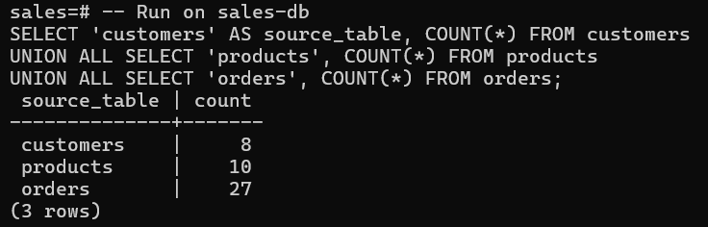
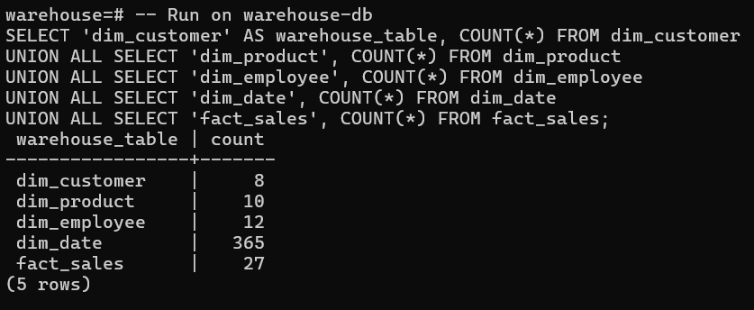

Task 4.3: Test the ETL Pipeline:
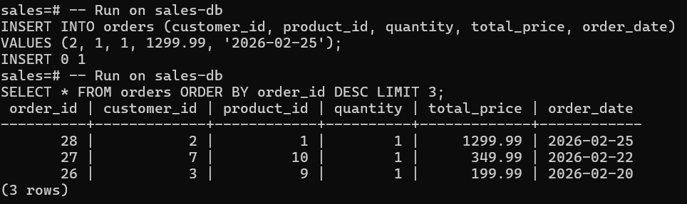
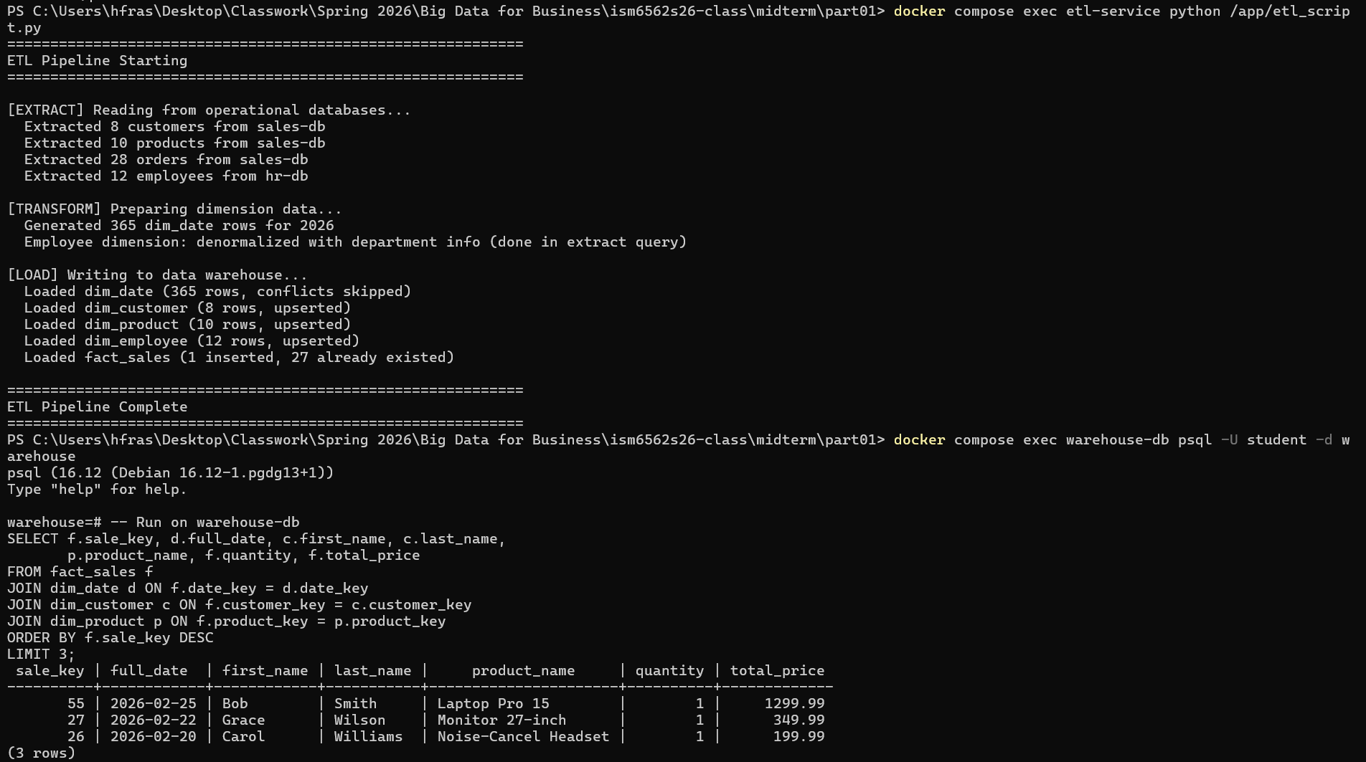

Part 5: Analytical Queries:
Task 5.1: Write Analytical Queries:
Queries are in SQL file in folder as well
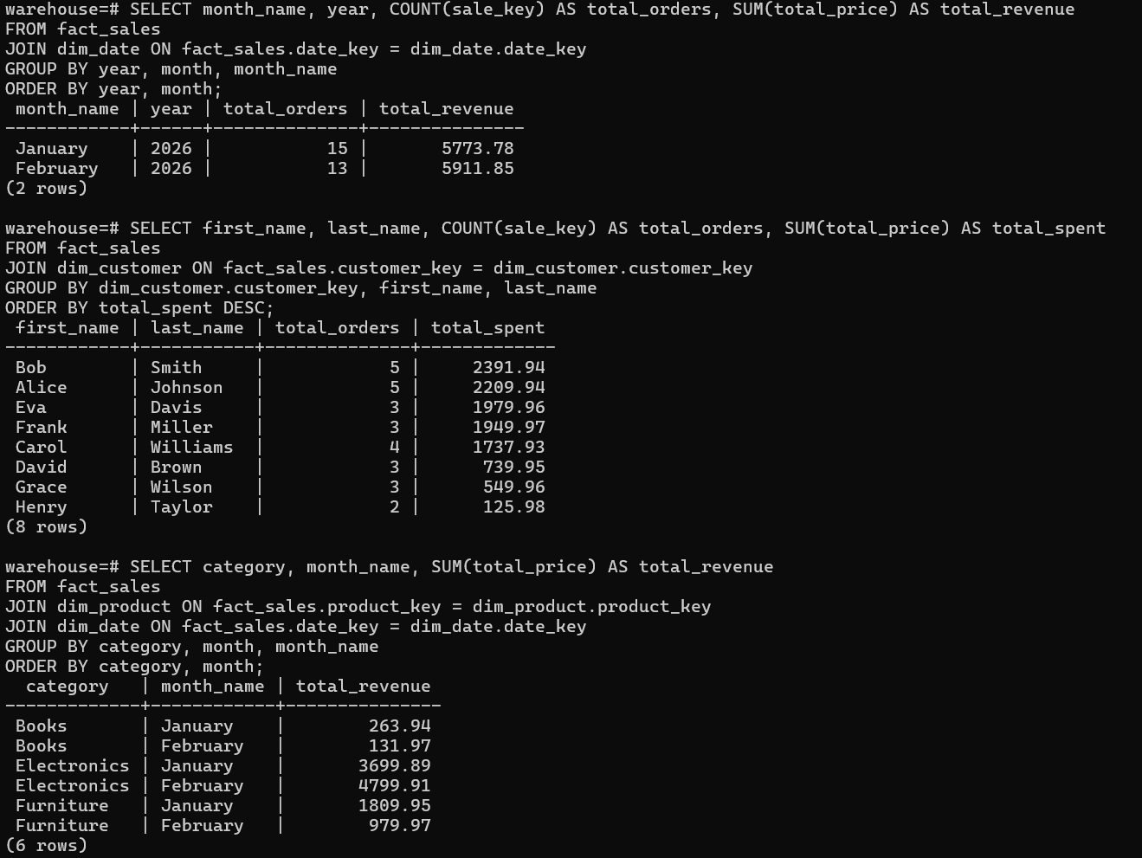
Task 5.2: EXPLAIN ANALYZE Comparison:
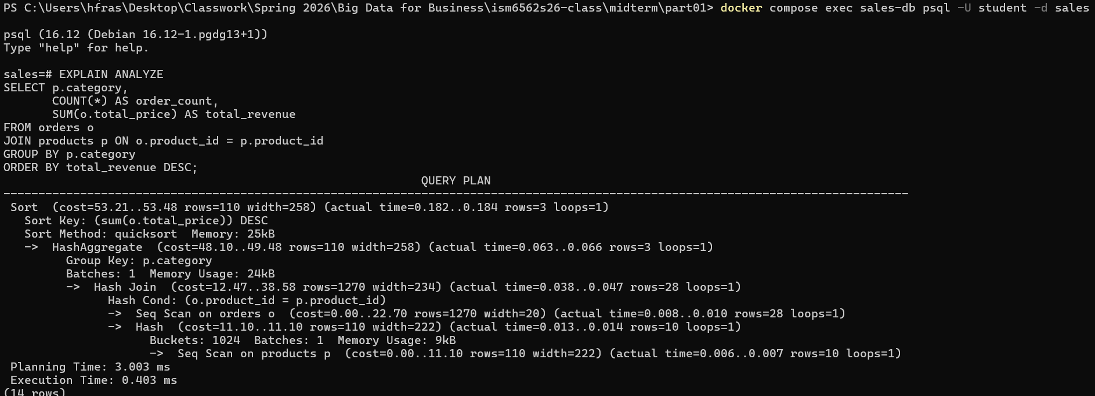
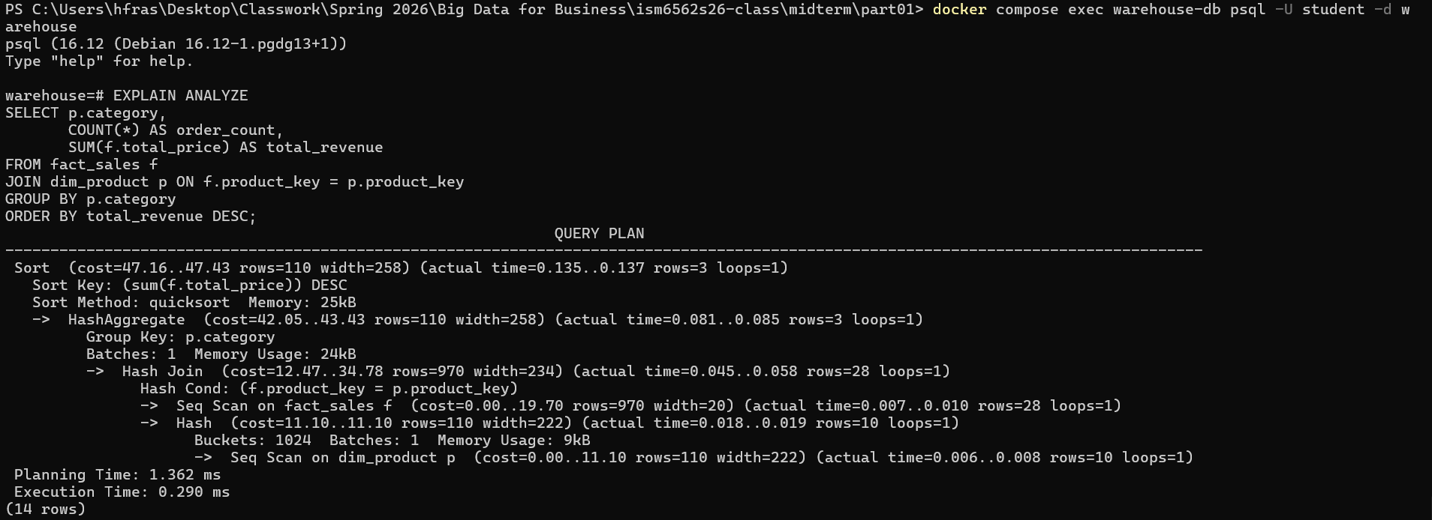
Both plans use sequential scans on all tables, meaning it will go through all of the table. This makes sense since the data is so small that looking up an index may take longer.
Both of the queries used a hash join. The operational query joins order to products and the warehouse query joins fact_sales to dim_product
Operational was planning 3.003ms, execution 0.403ms and warehouse was planning 1.362ms, execution 0.290ms.
This is such a small database that it does not matter, but at a large scale the seq scans would take a very long time we would need indexes, or even portioning. Also, the warehouse database is preprocessed denormalized structure so that means less data needs to be processed per row so it will be much faster.

